*Train Simulation*

Use Case Specification Document

**Case Id 4**

**Adjust Weather**

Version No. 2.0.0

Project Document Revision History

|  |  |  |  |
| --- | --- | --- | --- |
| **Version Number** | **Date** | **Revision Author** | **Description of Revision** |
| 1.0 | 3/14/19 | Abbass Srour | Initial Version |
| 2.0 | 4/16/19 | Maxx Achtman | Updating Use Case |

Table of Contents

**1. Introduction** **4**

**2. Use Case Information** **4**

2.1 Actors **4**

2.2 Use Case Interaction **4**

**3. Trigger** **6**

**4. Pre-condition(s)** **6**

**5. Post-Condition(s)** **6**

**6. Use Case Swimlane Diagram** **7**

**7. Main/Basic Flow(s) of Events** **8**

**8. Alternative/Exception Flow of Events** **9**

**9. Assumptions/Business Rules including Non-Functional Requirements** **9**

# 1. Introduction

To simulate real world conditions, the option to modify the weather is given to the user. The severity of the weather will directly correlate to the frequency of delays in the simulation on a given day. Some days will have greater delays than others due to varying weather conditions. A user may choose to enable this option and set severity prior to running the simulation This can only be used once a simulation is ran at the start of the program.

# 2. Use Case Information

## 2.1 Actors

|  |  |  |
| --- | --- | --- |
| **Actor Name** | **Role** | **Description** |
| User | Main Actor | The user will provide the data to the intensity of the weather prior to the simulation from using buttons for weather type and slider bar for severity. |
| Simulation System | Main Actor | The simulation system will ~~handle~~ recognize the user’s request and delay trains accordingly |
| Weather System | Main Actor | The weather system will generate the weather in a simulation from entered data provided by the user in the UI |
| UI System | Secondary Actor | UI System would allow the user to edit weather in the simulation from buttons for weather type and slider bar for severity |

## 2.2 Use Case Interaction

A list of predecessors use cases are as follows:

Use Case 1: Setup Initial State - The user would upload files for a simulation run to occur. Once files are read into the program, weather would be applied if it is applicable.

~~Create the initial state of a railroad system given a configuration file~~

Use Case 1: Setup the initial state - The user would upload files for a simulation run to occur. Once files are read into the program, weather would be applied if it is applicable.

Use Case 2: Add remove trains from the simulation - The user will be able to add or remove trains from text files in UI and Weather System would affect the timings for each train.

~~The user will be able to add or remove trains from simulation~~

Use Case 3: Edit track lines between nodes - The user will be able to modify links between stations and hubs. Weather System would create delays along the tracks if severity is strong enough to warrant delay.

~~The users will be able to modify the linking of stations and hub prior to the simulation being run.~~

A list of successors use cases are as follows:

Use Case 5: Update Graph - Graph would be updated according to files that are input by the user and any weather conditions that may be applied would be updated in the non-visual view of the graph.

Use Case 6: Run Simulation - Simulation would be ran for predefined amount of days as specified by user. Weather would affect the run if the severity is strong enough.

Use Case 7: Track Statistics - Statistics would be tracked throughout the simulation. Weather would affect the results if severity is strong enough.

Use Case 8: Recommended Changes - Offer recommended changes to simulation to improve efficiency.

~~Offer recommended changes to simulation to improve efficiency~~

Use Case 9: View Statistics about simulation - Users will be able to observe metrics that are accumulated through the simulation run.

Use Case 10: Rollback Simulation History - Allow users to compare results from current simulation to a previous point in time.

~~Allow users to compare results from current simulation to a previous point in time.~~

~~Use Case 9 –View Statistics about simulation~~

~~Users will be able to observe various metrics of train simulation results.~~

# 3. Trigger

The use case is triggered ~~after the user starts the simulation~~ once a simulation run ends and user chooses to enter the UI edit mode. Based off the setting the user chooses, the simulation will encounter delays based on the severity level of the weather.

# 4. Pre-condition(s)

4.1 Data is imported

4.2 Initial graph is created

4.3 ~~Trains are edited by user~~ User runs the first simulation of the program

4.4 User chooses to change weather type and severity in the edit view of the UI

# 5. Post-Condition(s)

5.1 After user has set a weather ~~level~~ type and severity level, the option with its severity is sent to the simulation to reflect the value.

5.2 Severity would be applied in future simulations until user chooses to change the weather type or severity

# 

# 6. Use Case Swimlane Diagram

~~OLD~~

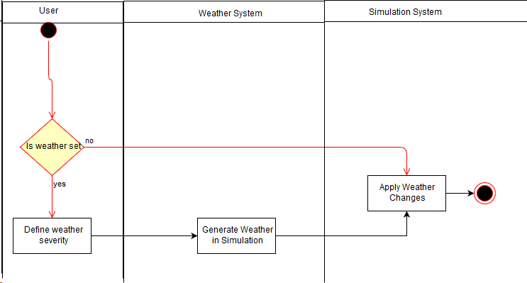

New

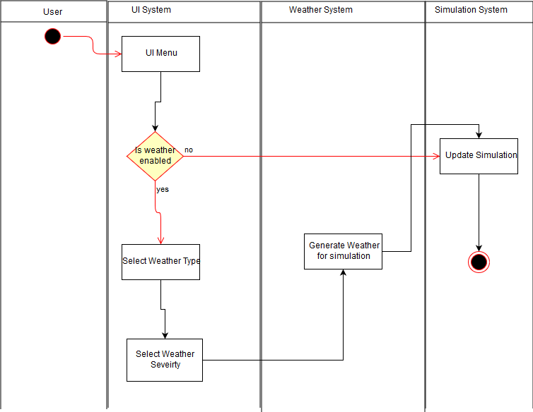

# 7. Main/Basic Flow(s) of Events

7.1 User will be given the choice of enabling weather or not

7.2 If weather is enabled, then the ~~severity of the weather must be chosen~~ weather type would be selected

7.3 Once weather type is selected, then weather severity would be defined by a slider bar

~~7.3 User must then edit or confirm changes~~

7.4 information is sent to the weather system

7.5 The weather system will generate random number and effect train delay times according

7.6 User will be able to run again with different setting or exit simulation

# 8. Alternative/Exception Flow of Events

~~Not Applicable~~

8.1 User would choose not to enable weather prior to a simulation run

# 9. Assumptions/Business Rules including Non-Functional Requirements

9.1 Simulation will be able to handle the weather request from the user.